***CalculatorTest with AAA, @Before, and @After***

package org.example;

import org.junit.After;

import org.junit.Before;

import org.junit.Test;

import static org.junit.Assert.*;

public class CalculatorTest {

private Calculator calculator;

// Setup: Runs before each test

@Before

public void setUp() {

System.out.println("Setting up...");

calculator = new Calculator();

}

// Teardown: Runs after each test

@After

public void tearDown() {

System.out.println("Cleaning up...");

calculator = null;

}

@Test

public void testAddition() {

// Arrange

int a = 10;

int b = 20;

// Act

int result = calculator.add(a, b);

// Assert

assertEquals("Addition should return sum", 30, result);

}

@Test

public void testSubtraction() {

// Arrange

int a = 20;

int b = 10;

// Act

int result = calculator.subtract(a, b);

// Assert

assertEquals("Subtraction should return difference", 10, result);

}

@Test

public void testMultiplication() {

// Arrange

int a = 5;

int b = 4;

// Act

int result = calculator.multiply(a, b);

// Assert

assertEquals("Multiplication should return product", 20, result);

}

@Test

public void testDivision() {

// Arrange

int a = 20;

int b = 4;

// Act

int result = calculator.divide(a, b);

// Assert

assertEquals("Division should return quotient", 5, result);

}

}

***Console output:***

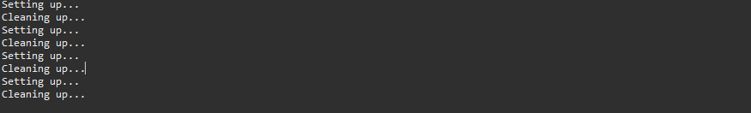

***Junit testcases:***

